**Requirements Document**

**Topic-interactive web browser**

**D2**

**advait trivedi 12bce0157**

**swapnil tiwari 12bce0318**

**ayush srivastava 12bce0045**

**Project statement:**

(a)We intend on developing an Interactive web browser.

(b)The browser will be interactive as well as accurate with respect to results as well as voice feedback.

(c)The only interactive web browser which is well known is google chrome which takes voice inputs for searching and navigating across the world wide web.We want to mimic this functionality along with voice output for the desired result.We will also try implementing gesture reorganization as a mode of search.

**Background information**

This project is basically from software development domain. The target users are all the people who use internet in their day to day life.

The most popular web browsers which is similar to ours is google chrome and opera. However we also intend on implementing voice output as one of our key functionality in our web browser. If time permits we will also try to implement gesture control.

**Stake holders:**

1) We as developers are the primary stake holders.

2) Other client users may include normal users who want a changed experience in web browsing.

3) Secondary or tertiary developers who would invest in this project for further growth . The best example being Microsoft who would be willing to implement this in their Internet explorer.

**Requirements:**

Functional requirement:

1) A web browser to browse through the internet with voice command.

2) Selective voice output for the particular search by user.

3) interactive searches and possible use of gesture control.

for example: If a user were to submit a request of say icc world cup by just saying it, the browser were to parse this and use it as a string search. The browser would then read out the top searches returned by the browser .

**Usecase Diagram:**

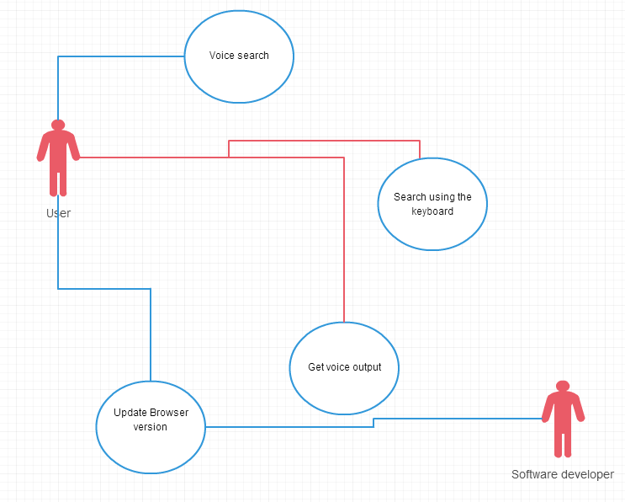

**Non Functional Requirement :**

RESPONSE TIME - We as developers will try to increase the response time of the search by the users. For instance a mal coded software may implement the same task in longer time, which might dissatisfy the user. We expect to implement our code keeping in mind user satisfaction, for instance we will keep in mind the voice input and output response time and sensitivity so the client is fully aware of the software being used.

Usability- Will try to execute in various windows dependent platform i.e. mobile and laptop. Since windows has diversified on other hardware platform such as mobile phones and tablets, we will test our software to be optimally compatible on these devices as well.

Security- Will implement complete abstraction of the back end technology behind the working of the browser. Security is imperative as any other windows app developer could extract the source code , and use it in his/her project , which is against our interest.